AIRIS3 Disclaimer and Safety Guidelines V1.0

Drone Delivery Solutions

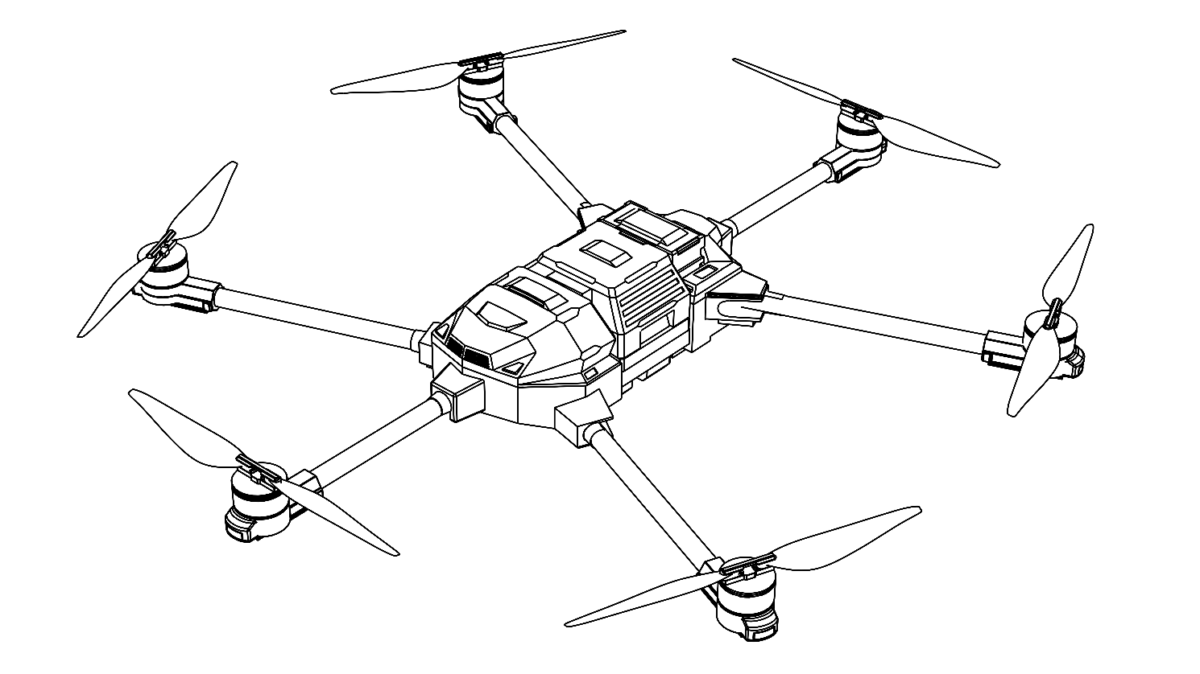

|  |  |
| --- | --- |
| <https://arc.delivery> |  |

Table of Contents

1. DISCLAIMER AND WARNING 1

2. KNOW BEFORE USE 2

3. CHECK ITEMS BEFORE USE 2

3.1 Remote Controller 2

3.2 Aircraft 3

3.3 Battery 3

3.4 Power system 3

3.5 Gimbal Camera 4

4. PRODUCT MAINTENANCE 4

4.1 Storage and Transportation 4

4.2 Maintenance 4

5. FLIGHT CONDITIONS REQUIREMENTS 5

5.1 Weather and Environmental Requirements 5

5.2 Flight Control and Wireless Communication Requirements 6

6. FLY SAFETY 6

6.1 Aircraft Return 6

6.2 Low battery 7

7. LEGAL REGULATIONS AND FLIGHT LIMITS 7

8. EXPORT CONTROLS 7

8.1 Comply with Application Export Control Laws 7

8.2 Export Compliance Disclaimer 7

# DISCLAIMER AND WARNING

This product is suitable for adults over 18 years old. Keep children out of reach of this product and it is strictly forbidden to use this product in the presence of children.

Before using this product, please read this document and the User Manual carefully. This has an important impact on your rights and interests.

ARC does not assume any responsibility for personal injury or property damage caused by the following reasons. Please read the following terms carefully:

* Obtained through informal channels, using non-company products or counterfeit products.
* Failure to properly install, set up and use the product according to the installation manual.
* Damage caused by unauthorized modification or replacement of parts or accessories not produced by our company, which results in malfunction of the aircraft.
* The user operates the aircraft when in poor physical or mental condition, such as drinking, taking drugs.
* Property damage and personal injury caused by the operator's subjective intent or improper operation.
* Malfunction of this product due to natural aging and wear of aircraft parts.
* Using this product in an environment that exceeds the harsh environment specified on this product.
* Use this product in conditions of limited visibility and obstructed vision.
* Users use this product in government air control areas and no-fly zones.
* Product damage caused by improper use.
* Property damage and personal injury caused by transporting dangerous goods.

The documentation for this product is subject to update without prior notice. Please visit the ***https://arc.delivery/*** and enter the product page for the latest news.

# KNOW BEFORE USE

To enable you to use this product safely and efficiently, ARC provides users with the following documents:

* *List of items*
* *Disclaimer and Safety Guidelines*
* *Installation Manual*
* *User Manual*

It is recommended that users use the " List of Items" to check to ensure that the parts are consistent with the list. First, please read the "Disclaimer and Safety Guidelines", and then follow the "Installation Manual" to complete the installation and understand the use process. Please refer to the “User Manual” for details. Before using this product, please make sure that you are familiar with the functions and operation methods of each component. If you have any questions when using this product, please contact ARC or ARC's authorized agent for technical support.

# CHECK ITEMS BEFORE USE

## Remote Controller

To avoid possible damage and loss, the following points must be observed:

1. Use each interface strictly according to the interface definition.
2. Please make sure the remote controller is connected to the Internet (via Wi-Fi or cellular network), otherwise the flight records cannot be uploaded. If you cannot provide the flight records to our ARC, ARC will not be able to analyze the cause of your product damage or accident, nor can it provide you with after-sales service.
3. Please make sure the battery is fully charged before each flight.
4. Adjust the antenna to the appropriate position for optimal communication.
5. If you find that the antenna is damaged, please contact ARC technical support for repair.
6. Replacing the remote control requires binding. Please refer to the user manual for specific operations.
7. Charge and discharge the battery every 3 months to extend the battery life.
8. When the battery level of the remote control is 0%, please charge it in time to prevent the battery from over-discharging and damaging the device due to long-term low-power storage. When not in use for a long time, please charge the battery to about 40% - 60% for storage.
9. Do not cover the heat sink of the remote control to avoid overheating the remote-control during operation and affecting its performance.

## Aircraft

To avoid possible damage and loss, the following points must be observed:

1. Use each part of the interface strictly according to the interface definition.
2. Do not short-circuit the interfaces on the aircraft body.
3. When preparing the aircraft (such as assembling, debugging, wiping, etc.), you must be careful to avoid injury.
4. When unfolding the arms, please fold them in order of M1 and M2 arms, then M3 and M5 arms, and finally M4 and M6 arms. When folding the arms, please fold the arms in the order of M1 and M2, then M4 and M6, and finally M3 and M5 arms, and clip the arms into the fixed frame on the side of the aircraft and secure them with the propeller holders, otherwise the arms may be damaged.
5. Do not block the video transmission antenna.
6. There are waterproof covers on many places on the drone body, so be sure to cover the waterproof covers when not in use to prevent water from entering and causing a short circuit.

## Battery

To avoid possible damage and loss, the following points must be observed:

1. Always use the specified type of battery recommended by ARC.
2. The maximum allowable voltage of the aircraft is 52.2V, please use it in strict accordance with the relevant safety regulations and the instructions of the battery itself and be sure to pay attention to safety.
3. Never rinse the battery with water.

## Power system

High-speed propellers and motors may cause injury or loss to people. Be sure to follow the following:

### Propeller

1. Before each flight, please make sure that all propellers are in good condition. If they are aged, damaged or deformed, please replace them before flying.
2. When performing any operation on the propellers, make sure the power supply remains turned off.
3. Since the blades are thin, please be careful when operating to prevent accidental scratches.
4. Before each flight, please check whether the propellers are installed correctly and tightened, and whether the blades are unfolded.
5. Do not get close to the rotating propellers and motors to avoid cuts.

### Motor

1. Make sure the motor is securely mounted and can rotate freely.
2. Do not modify the motor’s physical structure on your own.
3. After the motor stops rotating, do not touch the motor immediately to avoid burns.
4. Do not cover the motor exhaust port.

## Gimbal Camera

1. The gimbal contains precision parts. If they are hit or damaged, the gimbal performance may be damaged and degraded. Please keep the gimbal properly to avoid physical damage.
2. Do not apply external force to the gimbal while it is working.
3. Do not add other devices or objects to the gimbal, as this will affect the performance of the gimbal.

# PRODUCT MAINTENANCE

## Storage and Transportation

To avoid possible damage and loss, the following points must be observed:

1. Keep children away from aircraft components as wires and small parts may be dangerous to children.
2. When transporting, be sure to remove the battery from the aircraft and disconnect it.
3. If the aircraft needs to be stored for a long time or transported over long distances, please store it in a cool and dry place.

## Maintenance

To avoid possible damage and loss, the following points must be observed:

**1. Every Flight:**

* After each flight, clean the aircraft after it returns to normal temperature. Do not clean the aircraft immediately after it is working.
* Make sure the fuselage structure is intact, clean the fuselage with a soft brush or wet towel, and then wipe off the water stains with a dry towel.
* If there are foreign objects such as sand attached to the surface of the motor or propeller, it is recommended to clean the surface with a wet towel first, and then wipe off the water stains with a dry towel.
* Store the aircraft in a dry place.
* Wipe the surface of the remote control and the display with a clean wet towel (wring out the water).

**2. Every 20 Hours or 100 Landings:**

* Check if the propeller has cracks. If so, replace the blades.
* Check if the propeller is loose. If so, replace the gasket and evaluate whether the core blades need to be replaced.
* Check if the plastic and rubber parts are aging.

**3. Every Year or 1000 Hours:**

We recognize that our users put ARC equipment into a variety of demanding applications and rely on their equipment to perform reliably. ARC recommends that users return their equipment for inspection at the above intervals to ensure optimal long-term performance and reliability. Services include:

* Service bulletins and firmware updates.
* Comprehensive cleaning and fastener replacement (as needed).
* Full cleaning and fastener replacement (as needed).
* System-level testing and recertification.
* Do not repair the aircraft yourself. If there is any damage, please contact ARC or an ARC authorized agent for technical support.

# FLIGHT CONDITIONS REQUIREMENTS

## Weather and Environmental Requirements

Please fly and operate in good weather conditions. To avoid possible damage and losses, be sure to comply with the following:

1. Do not fly in bad weather, such as strong wind (wind speed 12m/s or above), heavy rain (rainfall 25mm or above in 24 hours), heavy snow, foggy weather, etc.
2. When flying, please keep the aircraft within sight and keep the aircraft at least 10 meters away from obstacles, people, water and other objects.
3. Do not operate the aircraft indoors.
4. In low temperature (0℃ to 10℃) environment, please ensure that the aircraft battery is fully charged and reduce the aircraft load, otherwise it may affect flight safety.

## Flight Control and Wireless Communication Requirements

1. Make sure to operate the aircraft in an open area.
2. To prevent interference between the remote control and other wireless devices, be sure to turn off other wireless devices in the same band before using the remote control
3. If multiple aircraft are used at the same time, ensure that the distance between each aircraft is more than 10 meters to avoid interfering with each other.
4. Always exercise caution when flying near sources of electromagnetic interference (e.g., high-voltage power lines, high-voltage transmission stations, television broadcast towers, etc.). When flying in the above places, the performance of the aircraft may be disturbed, and if the interference source is too large, the aircraft will not be able to fly normally.

# FLY SAFETY

To avoid possible damage and loss, the following points must be observed:

1. Users are not allowed to operate the aircraft while in a physically or mentally unwell state such as drinking or taking drugs.
2. After landing, be sure to turn off the power of the aircraft power and then turn off the remote controller.
3. It is forbidden to use this product to throw or launch any dangerous objects at buildings, people or animals.
4. It is prohibited to use this product for any illegal or improper behavior.

## Aircraft Return

1. In the case of poor signal, the return function will be invalid.
2. If there are tall buildings or mountains on the return route, it may affect the safety of the aircraft’s return. Therefore, please set the return altitude before using the return function each time.
3. Before executing a long-term automatic flight mission, be sure to test that the return function is normal to avoid property losses caused by unsuccessful return due to incorrect firmware or other problems.

## Low battery

1. When the battery is low, be sure to return the aircraft and land it to prevent the loss of power on the motor and damage to the aircraft, people, animals and property.
2. When the system detects low battery, the drone will automatically return or land, and customers are not allowed to cancel.？？？

# LEGAL REGULATIONS AND FLIGHT LIMITS

To avoid possible damage and loss, the following points must be observed:

1. It is forbidden to modify the aircraft or use it for purposes other than transportation.
2. Do not fly near manned aircraft.
3. It is forbidden to use aircraft at large events.
4. It is forbidden to operate aircraft in the no-fly zone prescribed by law.
5. Always stay alert during flight, stay away from crowds and avoid other aircraft in time.
6. It is forbidden to fly in airspace exceeding the specified altitude.
7. It is forbidden to use the aircraft to carry any illegal dangerous items.
8. The default maximum flight distance is 25 km. If the flight distance is long, the remaining power of the aircraft may not be enough to return the aircraft, so be sure to fly carefully.
9. Stay away from any tall buildings and crowds during the flight.

# EXPORT CONTROLS

## Comply with Application Export Control Laws

You are advised export, re-export, and transfer of the products are subjected to export control laws. Unless permitted by applicable export control laws or approved by relevant export control authorities, your use, sale, transfer, lease or other actions of this product must ensure that:

1. There will be no infringement of an embargo imposed by the export control laws.
2. Do not transact with end users prohibited by applicable export control laws.
3. The products are not intended for use in connection with armaments, nuclear, chemical or biological weapons, or missile technology applications.

## Export Compliance Disclaimer

You will be solely responsible for any violation of the applicable export control laws caused by your use, sale, transfer, rental of this product or other actions. ARC will not be responsible for your violation of applicable export control laws under any circumstances, and you will also indemnify ARC and its affiliates, managers, employees, agents, and representatives from any legal liability and damages arising from your aforementioned actions, and bear the relevant expenses, including but not limited to litigation costs, attorney fees, travel expenses, etc.